

**Cairo Higher Institute for Engineering,**   
**Computer Science and Management**

معهد القاهره العالي للهندسه وعلوم الحاسب والاداره

Project

**Covid-19**

**Android Tracking System**

Supervisor: Dr. Osama fathy

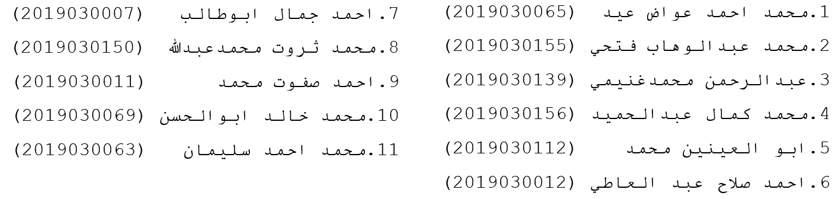Team name:

Cairo 2017

Table of Contents

List of Figures3

Abstract4

**Chapter 1**

1.1 Introduction5

1.2 Basic definitions 5

1.3 Overview 5

1.4 Problem definition 5

1.5 Project objectives 6

1.7 Conclusion 6

**Chapter 2**

2.1 Introduction 7

2.2 History of project 7

**Chapter 3**

3.1 Introduction 8

3.2 System Analysis 9

3.4 Conclusion 10

# List of Figures

Figure 3.1 Functional Diagram (page 8)

Figure 3.2 Flow Chart Diagram (page 9)

Figure 3.3 Context Diagram (page 10)

Figure 3.4 Data flow Diagram (page 10)

Figure 3.5 Sequence Diagram (page 11)

Figure 3.6 use-case Diagram (page 11)

Abstract

Coronavirus disease (COVID-19) is an infectious disease caused by the SARS-CoV-2 virus.  
This disease affect the lungs of human and Older people and those with underlying medical conditions like cardiovascular disease, diabetes, chronic respiratory disease, or cancer are more likely to develop serious illness. Anyone can get sick with COVID-19 and become seriously ill or die at any age.  
our project is an APP that could be predict if you have the Coronavirus or not by telling questions and you should select what is you have ?   
after this telling you the result and if you are illness with this disease tell you if your status if seriously and you must go to hospital now, isolate yourself at home or this not the Coronavirus.  
This APP tell you the total of total COVID cases in the world every time, and suggest to you hospitals you should go if you catch the coronavirus or suggest to you doctors who can help you to overcome this disease.

**Chapter One**

**Introduction and Purpose**

# Introduction

In this chapter we will talk about coronavirus (COVID-19)  
and the APP which we developed and Syndrome of coronavirus which cause of go to hospital or isolate yourself at home.

# Basic definitions:

COVID-19 coronaviruses are a type of virus SARS‑CoV‑2.  
SARS‑CoV‑2 is a shortcut Severe acute respiratory syndrome coronavirus 2 .

# Overview:

A new virus called Coronavirus and hits the world and Cause of many deaths last 2 years, we developed an APP that telling the user if he has the virus , isolate himself or have nothing and suggest the nearest hospital in   
his area and some doctors who have high efficiency in coronavirus disease.

# Problem definition:

A coronavirus is a kind of common virus that causes an infection in your nose, sinuses, or upper throat.  
Most coronaviruses aren't dangerous.  
In early 2020, after a December 2019 outbreak in China, the World Health Organization identified SARS-CoV-2 as a new type of coronavirus. The outbreak quickly spread around the world.  
COVID-19 is a disease caused by SARS-CoV-2 that can trigger what doctors call a respiratory tract infection. It can affect your upper respiratory tract (sinuses, nose, and throat) or lower respiratory tract (windpipe and lungs).

# Project objectives:

Peoples want to know if they have the virus or not, in our project we developed an APP to android predict if you have the virus by asking you some question that showing to user if he has this disease or not and telling him to go to hospital with suggest some of hospital which is nearest by him, or telling him you should isolate yourself in home with suggest same doctors that have high efficiency in your case, or you have nothing and you should don’t worry about this.

# Conclusion

Coronavirus is very dangerous to older peoples and it Lead to death.  
if you feels any Syndrome of coronavirus, you should go to hospital and make a coronavirus test to ensure .  
the coronavirus test not yourself but to your family that you must protect them not to copy the virus to them.

**Chapter 2**

**Overview about Project Name**

2.1 Introduction:

In this chapter we will discuss the Coronavirus when being started ,  
 what happen at this time ? and What did the World Health Organization do then? And illustrate Coronaviruses kinds.

2.2 History of COVID-19

On 31 December 2019, WHO was informed of cases of pneumonia of unknown cause in Wuhan City, China. A novel coronavirus was identified as the cause by Chinese authorities on 7 January 2020 and was temporarily named “2019-nCoV”.  
Coronaviruses (CoV) are a large family of viruses that cause illness ranging from the common cold to more severe diseases. A novel coronavirus (nCoV) is a new strain that has not been previously identified in humans. The new virus was subsequently named the “COVID-19 virus”.

On 30 January 2020, Dr Tedros Adhanom Ghebreyesus, WHO Director-General declared the novel coronavirus outbreak a public health emergency of international concern (PHEIC), WHO's highest level of alarm. At that time there were 98 cases and no deaths in 18 countries outside China.

On 11 March 2020, the rapid increase in the number of cases outside China led the WHO Director-General to announce that the outbreak could be characterized as a pandemic. By then more than 118 000 cases had been reported in 114 countries, and 4291 deaths had been recorded.

By mid-March 2020, the WHO European Region had become the epicenter of the epidemic, reporting over 40% of globally confirmed cases. As of 28 April 2020, 63% of global mortality from the virus was from the Region.

Since the first cases were reported, WHO has worked around the clock to support countries to prepare and respond to the COVID-19 pandemic. In the words of Dr Hans Henri P. Kluge, WHO Regional Director for Europe, “Through transparent knowledge-sharing, tailored support on the ground, and steadfast solidarity, we will beat COVID-19.”

**Chapter Three**

**System Analysis**

# 3.1 Introduction

# Our application Coronavirus (COVID-19) Self-Checker helps you quickly find information about the new coronavirus and COVID-19, the disease it causes. Use our interactive tool to:

# • Check yourself for coronavirus symptoms.

# • Learn how to protect yourself and others from COVID-19.

# • Get coronavirus information important to parents and caregivers.

# 3.2 System Analysis

## 3.2.1 System Functional Diagram (FD)

We introduce in this section FD for the system and discuss of it Function diagram is a process of divisions from a higher function Appropriate smaller function which shown in the figure 3.1.

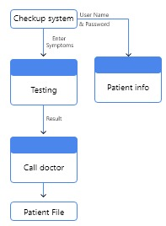

Figure 3.1 Functional Diagram

## 3.2.2 System Flow Chart Diagram

Figure 3.2 Flow Chart Diagram

A flowchart is a type of diagram that represents an algorism, workflow or process, showing the steps as boxes of various kinds, and their order by connecting them with arrows. This diagrammatic representation illustrates a solution model to a given problem. Flowcharts are used in analyzing, designing, documenting or managing a process or program in various fields.

## 3.2.3 Context Diagram

Figure 3.3 Context Diagram

AContext Diagram (CD) in software engineering and systems engineering is a diagram that defines the boundary between the system, or part of a system, and its environment, showing the entities that interact with it.This diagram is a high level view of a system.

## 3.2.4 Data Flow Diagram (DFD)

Figure 3.4 Data flow Diagram

A Data Flow Diagram (DFD) is a graphical representation of the "flow" of data through an information system, modelling its process aspects. A DFD is often used as a preliminary step to create an overview of the system, which can later be elaborated. DFDs can also be used for the visualization of data processing (structured design).

## 3.2.5 Sequence Diagram

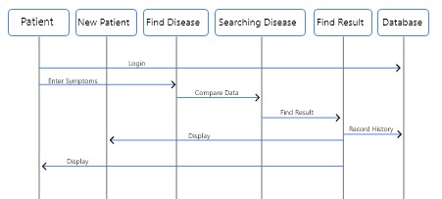

Figure 3.5 Sequence Diagram

A sequence diagram shows, as parallel vertical lines (lifelines), different processes or objects that live simultaneously, and, as horizontal arrows, the messages exchanged between them, in the order in which they occur. This allows the specification of simple runtime scenarios in a graphical manner.

## 3.2.6 Use-case Diagram

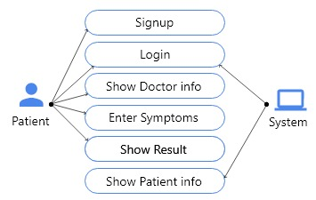

# Figure 3.6 use-case Diagram

A usecasediagram at its simplest is a representation of a user's interaction with the system that shows the relationship between the user and the different use cases in which the user is involved. A use case diagram can identify the different types of users of a system and the different use cases and will often be accompanied by other types of diagrams as well.

**References**

Sites references:

1. Coronavirus. (2022). Retrieved 16 February 2022, from <https://www.who.int/health-topics/coronavirus#tab=tab_1>
2. Severe acute respiratory syndrome coronavirus 2 - Wikipedia. (2022). Retrieved 16 February 2022, from <https://en.wikipedia.org/wiki/Severe_acute_respiratory_syndrome_coronavirus_2>
3. Coronavirus (COVID-19) Overview. (2022). Retrieved 16 February 2022, from <https://www.webmd.com/lung/coronavirus>
4. About the virus. (2022). Retrieved 16 February 2022, from <https://www.euro.who.int/en/health-topics/health-emergencies/coronavirus-covid-19/novel-coronavirus-2019-ncov>
5. About the virus. (2022). Retrieved 16 February 2022, from <https://www.euro.who.int/en/health-topics/health-emergencies/coronavirus-covid-19/novel-coronavirus-2019-ncov>
6. Coronavirus: Europe now epicenter of the pandemic, says WHO. (2022). Retrieved 16 February 2022, from <https://www.bbc.com/news/world-europe-51876784>